K/DA - POP/STARS (ft. Madison Beer, (G)I-DLE, Jaira Burns) | Music Video - League of Legends

<https://www.youtube.com/watch?v=UOxkGD8qRB4>



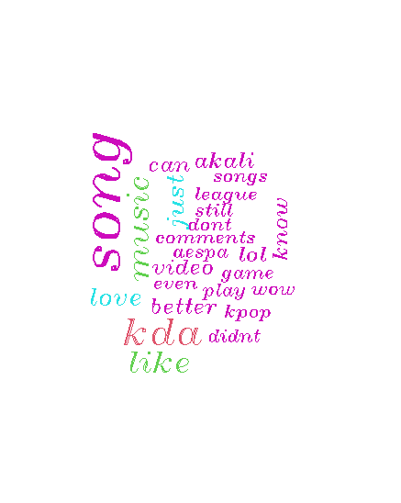

Burn It All Down (ft. PVRIS) | Worlds 2021 - League of Legends

<https://www.youtube.com/watch?v=1Z6CHioIn3s&t=137s>





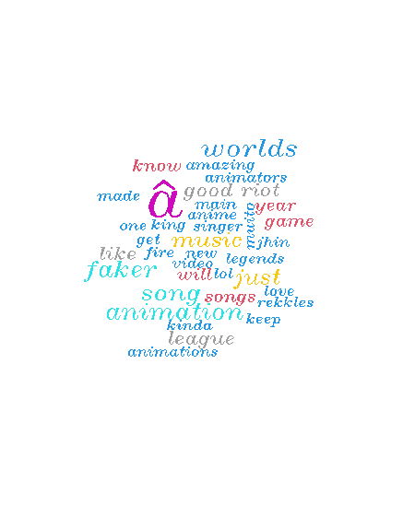

Search Result = League of Legends

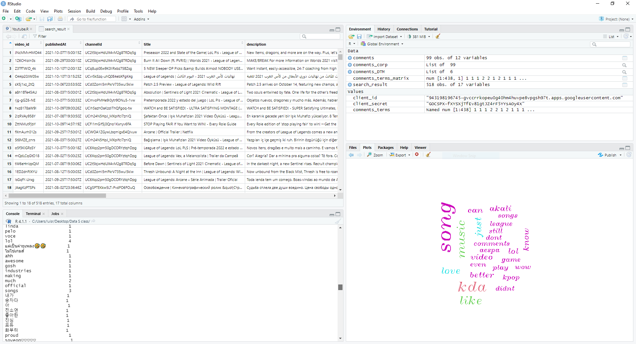

**Discussion**

The data that I decided to collect are from two songs made by different bands but are released by the same company that owns league of legends. The company tends to release a song when the championship comes up every year. The first one by K/DA blew up so much since it was made by Korean pop singers and American’s singers. The video was able to grow a total of 456 million views over the years and over 257 thousand comments. While the song Burn it All Down was released in September 28 this year and has gotten over 10 million so far. The player base seems to love the K-Pop music more since when K/DA song released in 2018 the video blows up way faster. Even with this in mind, the video is not bad at all, and the comments suggest that. Considering both word clouds have similar words, they display the enjoyment form the viewers about the video and the song. The word love is mentioned a lot in the comments on both songs which causes the word to display in the word cloud. Also to consider the word cloud seems to pick up some words that don’t seem to be in the English language which leads to believe that must be the comment from the player base from out of USA.